October 14, 2019

To our Valued Partners,

For some time now, we’ve been building our new manufacturing center in order to provide a stronger platform for growth and enhance our products even further. I acknowledge that, over the last several weeks, we have not delivered the product we had hoped. I apologize for the inconvenience and challenges this may have caused you and your business.

I also wanted to take a moment to update you on our progress and let you know of our plans to take care of you going forward.

Our Progress:

Currently, we are producing in our new plant in West Virginia and are excited by the quality and performance of what is being made. Our new manufacturing space is a dedicated, allergen-free, plant-based area hosting our improved products, complete with our new packaging. We’ve invested in new, state-of-the-art equipment to support our proprietary processes and we’re very pleased with the results. This being said, I would like to fully acknowledge that it’s taken longer than we expected to secure all certifications and bring the new systems fully on-line.
Delivery:

Regarding product delivery, I anticipate being able to ship all orders by the 25th of October, and hopefully sooner. Getting product into your hands as quickly as possible remains our highest priority. We will be in contact soon to confirm shipping dates and will continue to provide updates in a timely manner.

Again, please accept my sincere apology for the delay in supply. We hope to swiftly return to providing you with 100% satisfaction.

If you have any remaining questions, please reach out to Rainy Martin, VP of Business Operations, or feel free to contact me directly.

Sincerely,
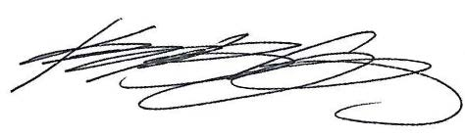

Kelly Coffin, CEO

